

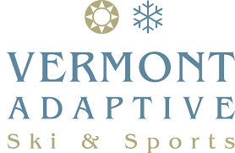

Join us for some **FREE** groovy music and aquatic dancing…

**WATER AEROBICS**

Where: UVM Patrick Gymnasium Pool

When: Sunday, December 3

Time: 1:00 – 2:00 pm

RSVP: Kelly Walsh – 802-353-3178, truenorth@vermontadaptive.org

